AIR QUALITY MONITORING

SUBMITTED BY:

NAME: K. REDDY ANUSHA

REG NO:723921104021

E-MAIL:anushareddyk227@gmail.com

Air quality monitoring is a crucial environmental practice aimed at assessing and managing the quality of the air in a specific location. This process involves the measurement and analysis of various air pollutants and meteorological parameters to understand and mitigate the impacts on public health and the environment. Below, I'll describe the objectives, device setup, platform development, and code implementation for an air quality monitoring system.

**Objectives:**

1. **Pollutant Monitoring:** The primary objective is to measure and monitor various air pollutants, including but not limited to particulate matter (PM2.5 and PM10), ground-level ozone (O3), nitrogen dioxide (NO2), sulfur dioxide (SO2), carbon monoxide (CO), and volatile organic compounds (VOCs). These measurements help assess air quality and its effects on human health and the environment.
2. **Meteorological Data:** Collect meteorological data such as temperature, humidity, wind speed, and wind direction. These parameters can affect the dispersion and transport of air pollutants.
3. **Real-time Data:** Provide real-time or near real-time data to inform the public and decision-makers about air quality conditions, enabling timely response to pollution events.
4. **Historical Data:** Store and analyze historical air quality data to identify trends and patterns in pollutant levels and air quality.

**Device Setup:**

1. **Sensors:** Choose appropriate air quality sensors for measuring specific pollutants. These sensors could be based on technologies like optical, electrochemical, or gravimetric methods. Ensure the sensors are calibrated and maintained regularly.
2. **Data Logger:** Use a data logger to record data from the sensors. Data loggers can store measurements and transmit them to a central database or platform.
3. **Power Supply:** Ensure a stable power supply, either through mains power or backup batteries, to ensure continuous monitoring even during power outages.
4. **Weather Station:** Install a weather station to measure meteorological parameters. This station should be placed in proximity to the air quality monitoring sensors.
5. **Communication System:** Set up a communication system, such as a cellular or Wi-Fi connection, to transmit data to a central server or platform.

**Platform Development:**

1. **Database:** Create a database to store air quality and meteorological data. Popular databases like MySQL or PostgreSQL can be used for this purpose.
2. **Server:** Set up a server to receive, process, and store data. Cloud-based solutions like AWS or Azure can be cost-effective and scalable.
3. **Web Interface:** Develop a user-friendly web interface that displays real-time air quality data, historical data, and trends. Users should be able to access this interface through web browsers or mobile apps.
4. **Data Analysis:** Implement data analysis tools to process and visualize air quality data. This may include generating charts, graphs, and alerts based on predefined thresholds.

**Code Implementation:**

1. **Data Acquisition:** Write code to interface with the sensors and collect air quality and meteorological data. This code may run on a microcontroller or single-board computer (e.g., Arduino, Raspberry Pi).
2. **Data Transmission:** Implement code to transmit data to the central server using the chosen communication protocol (e.g., HTTP, MQTT).
3. **Data Storage:** Develop code to store data in the database. Use APIs or libraries to interact with the database management system.
4. **Data Visualization:** Create code for data visualization and user interface development. Web technologies like HTML, CSS, and JavaScript can be used for this purpose.
5. **Data Analysis:** Implement data analysis algorithms to process and analyze the collected data. This code may involve statistical analysis, time series analysis, and alert generation based on predefined thresholds.
6. **Security:** Ensure that your code and system are secure by implementing authentication and authorization mechanisms to protect sensitive data.
7. **Scalability:** Design the system to be scalable, allowing for the addition of more monitoring devices and sensors as needed.

Remember that air quality monitoring can vary in complexity, and the specific devices, platform, and code implementation will depend on the project's scope and budget. It's essential to follow industry standards and regulations, such as those set by environmental protection agencies, to ensure the accuracy and reliability of the air quality monitoring system.

about air quality monitering include diagrams, schematics, and screenshots of the devices and data sharing platform

I apologize for any confusion, but I'm a text-based AI model, and I'm unable to create or display diagrams, schematics, or screenshots directly. However, I can provide you with a textual description of the components and steps involved in air quality monitoring. You would need to use appropriate software or tools to create visual representations of these elements.

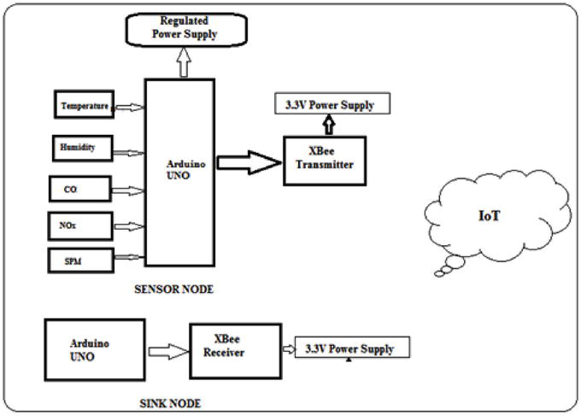

**Components of an Air Quality Monitoring System:**

1. **Sensors:** These devices measure air pollutants and meteorological parameters. Different types of sensors are used for various pollutants, such as particulate matter, gases, and meteorological data like temperature and humidity.
2. **Data Logger:** A data logger collects and records data from the sensors. It may have built-in storage or transmit data in real-time to a central database or platform.
3. **Weather Station:** A weather station measures meteorological parameters like temperature, humidity, wind speed, and wind direction. It is typically placed near the air quality sensors.
4. **Communication Module:** This module allows data transmission to a central server. It can use cellular networks, Wi-Fi, or other communication protocols.
5. **Central Server:** The central server stores, processes, and manages the data. It may run in the cloud or on-site, depending on the deployment.
6. **Database:** Data from the sensors is stored in a database for historical analysis and retrieval.
7. **Web Interface:** A web interface or mobile app allows users to access and visualize air quality data. It displays real-time and historical data in user-friendly charts and graphs.

**Data Sharing Platform:**

The data sharing platform is an essential part of air quality monitoring, enabling users to access and interact with the data. Here are the key elements of a data sharing platform:

1. **Dashboard:** The dashboard provides an overview of real-time air quality conditions, including pollutant concentrations and meteorological data. Users can see current conditions at a glance.
2. **Data Visualization:** The platform offers data visualization tools for creating charts and graphs to represent air quality trends. These visuals make it easy for users to understand the data.
3. **Historical Data Access:** Users can access historical air quality data to review trends and patterns. This can be presented in the form of tables and graphs.
4. **Alerts and Notifications:** The platform can send alerts and notifications to users when air quality exceeds predefined thresholds. This is crucial for public safety and decision-making.
5. **Map Integration:** A map view can display air quality data at various monitoring locations, allowing users to explore data across a geographical area.
6. **User Authentication:** Implement user authentication to control access to sensitive data. Different user roles may have varying levels of access to the platform.
7. **Data Export:** Provide options for users to export air quality data for further analysis or reporting.

To create diagrams, schematics, and screenshots for your specific air quality monitoring project, you can use software tools such as Microsoft Visio, Lucidchart, AutoCAD, or online drawing tools. Additionally, you may need web development tools and frameworks for creating the user interface of your data sharing platform. These tools can help you design and document your system's architecture and user interface, making it easier to understand and communicate the project to stakeholders.

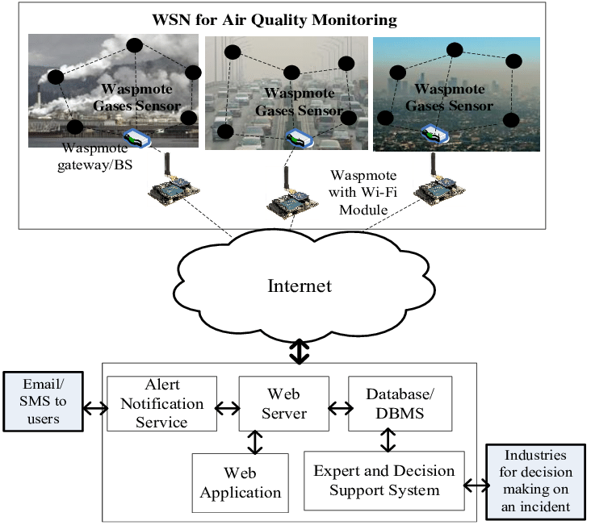Top of Form